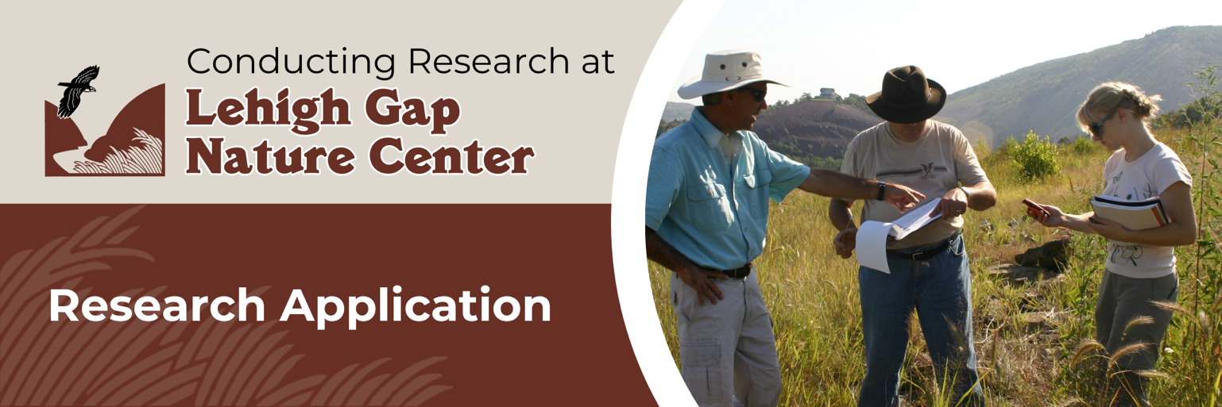

Lehigh Gap Nature Center believes in utilizing science to inform all habitat management and natural resource issues on our wildlife refuge, and we value our partners who help us collect and analyze that information. Featuring a diversity of native habitats, including over 400 acres of restored grassland on the Palmerton Zinc Pile Superfund site, the Lehigh Gap Wildlife Refuge offers unique opportunities for college and university research. Our Refuge is an outdoor laboratory, where professional and student researchers can make meaningful contributions to the ongoing recovery of the Superfund site and broaden scientific knowledge in the areas of ecology, geology, anthropology, and other disciplines.
To initiate a research partnership with LGNC, please read LGNC’s research expectations and answer all application questions below. Please limit your responses to two pages or less (not including this page). Submit the completed application electronically to mail@lgnc.org or via mail to Lehigh Gap Nature Center, P.O. Box 198, Slatington, PA 18080.

Researcher Expectations

Researchers must agree to abide by the following expectations established by LGNC and the Environmental Protection Agency:
- Advise LGNC via email or phone when you will be working on the site
- Abide by all safety rules and restrictions set by LGNC or EPA
- Provide GPS coordinates and/or GIS files for the project site
- Be aware of other ongoing research so as not to interfere with the studies of others
- Provide periodic (six-month) progress reports and notify LGNC of any major changes in protocols or research directions from what was described in the original application
- Submit research results and data to LGNC upon completion of the project
- Acknowledge LGNC in all presentations and publications resulting from the research and provide copies of the publications to LGNC

Application Timeline and Fee Schedule

Please allow three weeks for the approval process if no samples are being collected and five weeks if sampling is involved that will require EPA and/or Responsible Party approval.

To offset the time incurred by LGNC staff to approve, manage, and coordinate projects, LGNC charges a modest research fee assessed to the institution. The fee will be due upon acceptance of the project and must be paid before access is granted to the Refuge. The current fee schedule is as follows:

Undergraduate research fee: $50

Graduate research fee: $100

Contact Information

Name of Primary Researcher(s):

Academic Institution:

Address of Institution:

Researcher Email and Phone Number:

Name of Research Advisor (if applicable):

Research Advisor Email and Phone Number:

Project Proposal

- What are the goals of the proposed project, and how do they align with the LGNC goals and EPA goals/restrictions for the Palmerton Superfund site? See LGNC’s current strategic framework, available at lgnc.org.

- Where on the Lehigh Gap Wildlife Refuge would the research take place? (Please submit a map if possible.

- When do you plan to begin and end the research?

- What samples are being removed, in what quantities, for what purpose, and how might potentially hazardous materials be disposed of off-site?

I accept the conditions for research as outlined above, and I understand that failure to comply with procedures can result in termination of the research project.

_____________________________________________________
Primary Researcher Signature

